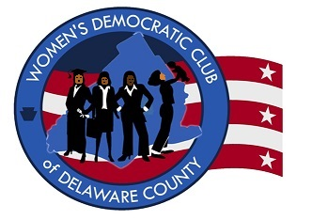

Women’s Democratic Club of Delaware County
P.O. Box 615
Springfield, PA 19064
Dr. Mary Ellen Balchunis, President

WOMEN'S DEMOCRATIC CLUB OF DELAWARE COUNTY
“WDCDC”
2019 COLLEGE STUDENT SCHOLARSHIP AWARD

Eligibility: Any Delaware County woman who is enrolled in the junior class of an accredited college or university and in good academic standing, is a registered Democrat, and has a background of community service and participation in the activities of the Democratic Party.

Award: $1,000

Name ________________________________________________________________
Home Address _______________________________________________________
Phone _______________________ E-Mail _________________________________
Birth Date ___________________ Year of Graduation ___________________
Name of College or University_______________________________________
Major/Minor ______________________________ Current GPA _____________
Activities ____________________________________________________________
_______________________________________________________________________WITH THIS APPLICATION SUBMIT THE FOLLOWING:
I. ONE PAGE ESSAY EXPLAINING
A. Your professional goals
B. Your Democratic Party activities
C. Your past and present involvement in your community
II. LETTER OF RECOMMENDATION FROM A FACULTY MEMBER IN YOUR MAJOR
III. LETTER OF SPONSORSHIP FROM A WDCDC MEMBER
MAILED DIRECTLY BY YOUR SCHOOL TO WDCDC:
A sealed official transcript from your college/university registrar

Mail to: WDCDC Scholarship, P.O. Box 615, Springfield, PA 19064
Deadline – Application and Transcript Received by May 6, 2019
For further information - Janet Lis jmlis@aol.com 610-742-6777
http://www.delcowomendems.com

